G H Patel College of Engineering & Technology
(The Charutar Vidya Mandal (CVM) University)
Civil Engineering Department
Expert Talk on
“Intelligent Infrastructure in Transportation and Management”

(Under the Banner of IIC, CVMU and GCET)

- Date: 8th October, 2025

- Time: 10 am onwards

- Institute: G H Patel College of Engineering & Technology

- Venue: G203, Civil Engineering Department. GCET

- Coordinator: Dr. Snehal Popli

- Convenor: Dr. Khadeeja Priyan

- No of Participants: 28 Students, 6 Faculty Members

- Report of Expert talk

Department of Civil Engineering, GCET has organized an expert talk on “Intelligent Infrastructure in Transportation and Management” on 8th October, 2025. The talk was delivered by Dr. Jiten Shah, Associate Professor, Civil Engineering Department, IITRAM, Ahmedabad.

About The talk:

Dr. Jiten shah started his talk by discussing intelligent infrastructure in transportation and management refers to the integration of advanced information and communication technologies, sensor networks, and real-time data analytics into the transportation system to improve safety, efficiency, and sustainability. ITS applications include real-time traffic monitoring, adaptive signal control, driver assistance systems, and dynamic route planning to reduce congestion, prevent accidents, and optimize travel for users.

- He also mentioned about the Sensors: Infrastructure-based sensors (in roads, traffic lights) and on-board sensors (in vehicles) collect real-time data on traffic flow, vehicle performance, and road conditions. He discussed about Communication: These sensors communicate with each other and a central system using advanced communication technologies to share information.
- Data Analytics & Algorithms: Intelligent algorithms analyze this data to provide real-time insights, predict traffic patterns, and automate adjustments to the transportation system.

This intelligence is then applied to a range of systems, including intelligent traffic signal control, autonomous vehicle technology, dynamic route planning, and real-time public transit tracking.

Dr. Shah discussed about Key Benefits such as Improved Safety: Reduces accidents through better traffic management and driver assistance features. Increased Efficiency: Optimizes traffic flow, reduces congestion and journey times, and improves the utilization of road networks. Enhanced Sustainability: Decreases energy consumption and emissions, contributing to environmental goals. Better User Experience: Provides travellers with real-time information, improving their journey and overall experience. Data-Driven Decisions: Enables proactive, real-time adjustments and planning, moving away from traditional methods based on historical data alone

Dr. Shah discussed about ITS applications in Traffic management, Driver Assistance, Public Transit, and in smart cities. He discussed the use of AI and ML techniques to improve the quality of roads and in management of traffic.

Photographs:

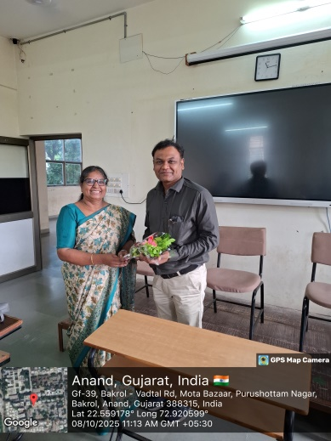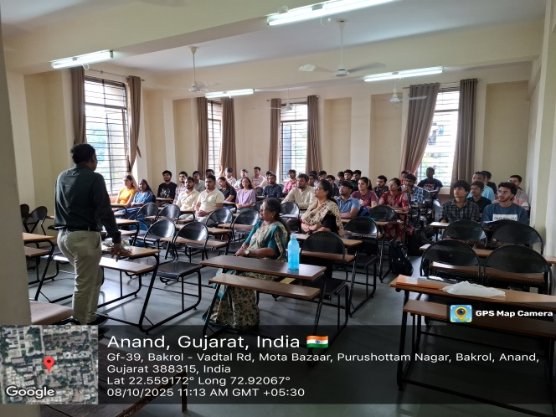

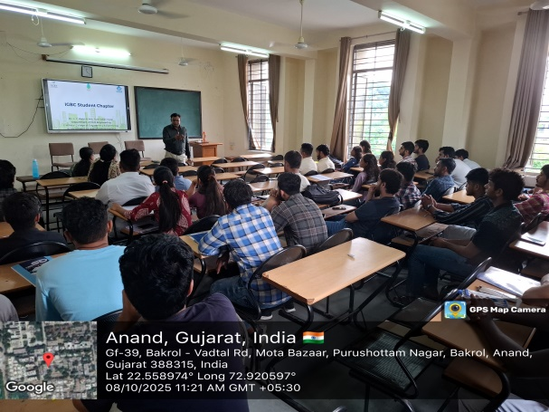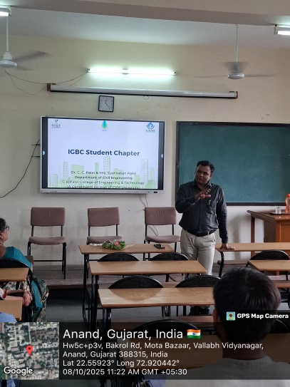

- List of Participants:

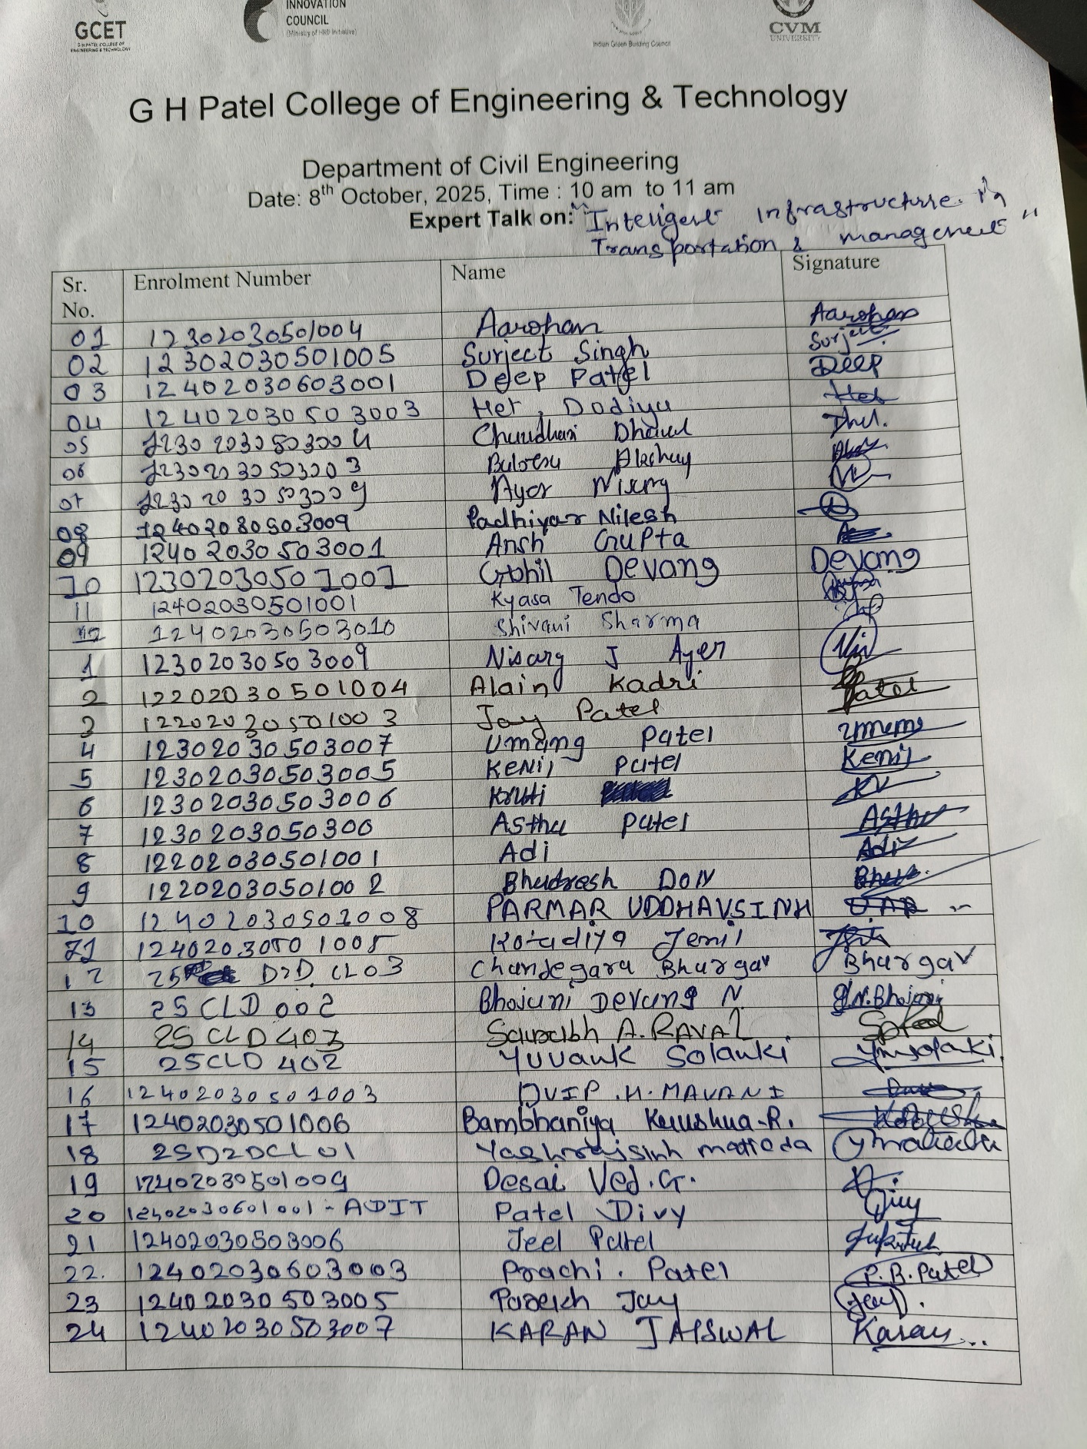
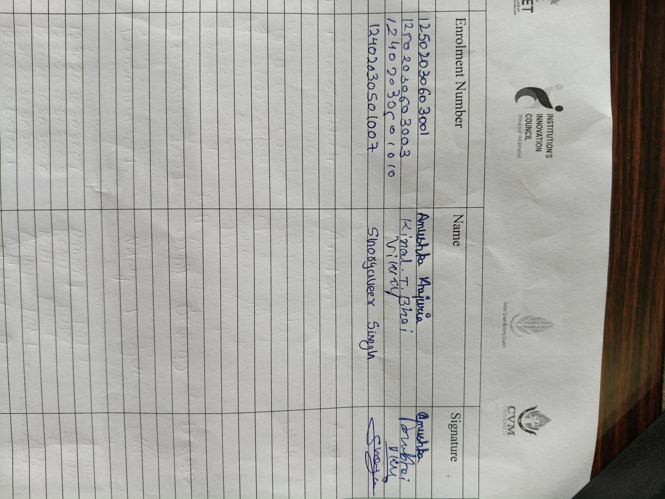

Poster of the Event:
