Expert Talk on "Lean Start-up and Minimum Viable Product/Business”

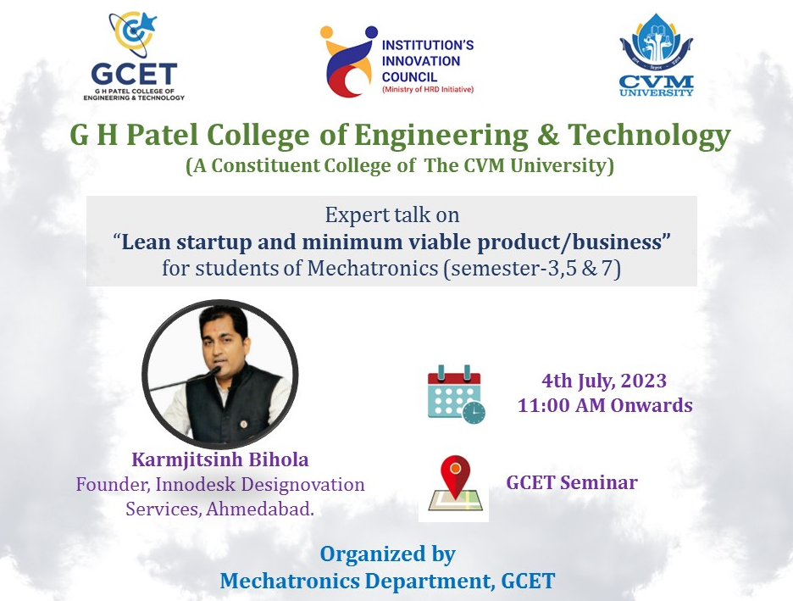
Mechatronics Department of G H Patel College of Engineering and Technology organized an expert talk on "Lean Start-up and Minimum Viable Product/Business" on 04th July 2023.
The expert talk aimed to achieve the following objectives:
- Provide an understanding of lean start-up methodologies.
- Explain the concept of minimum viable product/business.
- Highlight the importance of agility, iteration, and customer feedback in start-ups.
- Explore real-world case studies and success stories of lean start-ups.
- Encourage students to apply these principles in their future entrepreneurial endeavours.
Mr. Karmjitsinh Bihola, (Founder at Innodesk Designovation Services, Ahmedabad) shared his vast knowledge and experiences during the talk. He covered several important aspects of lean start-ups and minimum viable product/business.

- Lean Start-up Methodologies:
  - Introduction to the lean start-up approach and its core principles.
  - Exploring the concept of validated learning and rapid experimentation.
  - Understanding the build-measure-learn feedback loop and its significance.
  - Discussion on the importance of pivoting and adapting based on customer feedback.
  - Strategies for reducing waste and increasing efficiency in start-up operations.

- Minimum Viable Product/Business:
  - Defining the concept of minimum viable product/business (MVP/MVB).
  - Explaining how MVP/MVB serves as a learning tool and helps in early validation.
  - Identifying the key elements and characteristics of a successful MVP/MVB.
  - Case studies of well-known companies that utilized MVP/MVB to their advantage.
  - Best practices for developing and launching an effective MVP/MVB.
During interactive session students discussed about the initial stages of Start-up. The session facilitated a fruitful discussion on various topics related to lean start-up methodologies and MVP/MVB.
The event provided valuable insights into the lean start-up approach and the concept of minimum viable product/business. The students gained knowledge about the methodologies, techniques, and real-world examples of successful lean start-ups. It is hoped that this talk will inspire and encourage students to apply these principles in their future entrepreneurial endeavours.
Mechatronics Department would like to extend its gratitude to Mr. Karmjitsinh Bihola for his engaging and enlightening talk. Special thanks to the organizing committee, faculty members, and students who actively participated in making this event a success.
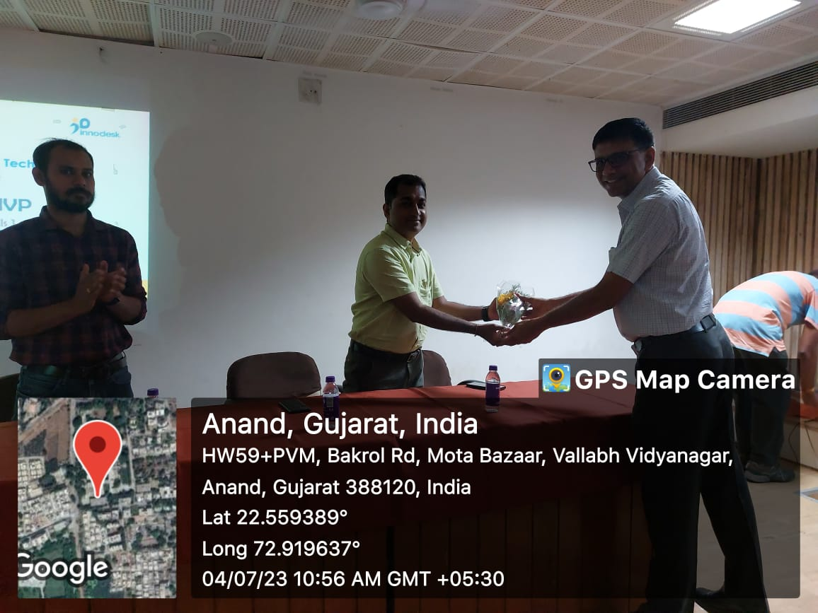 | 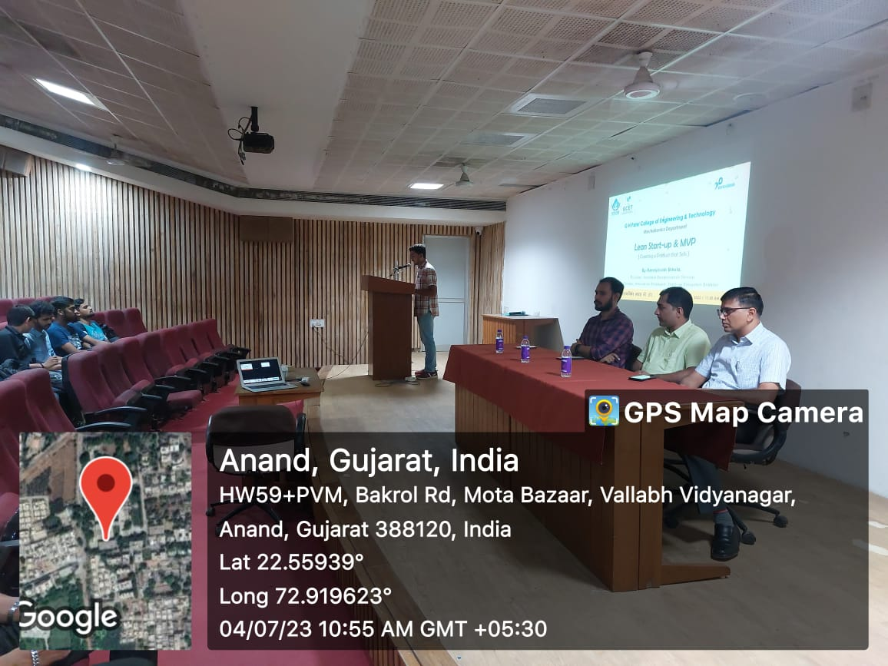
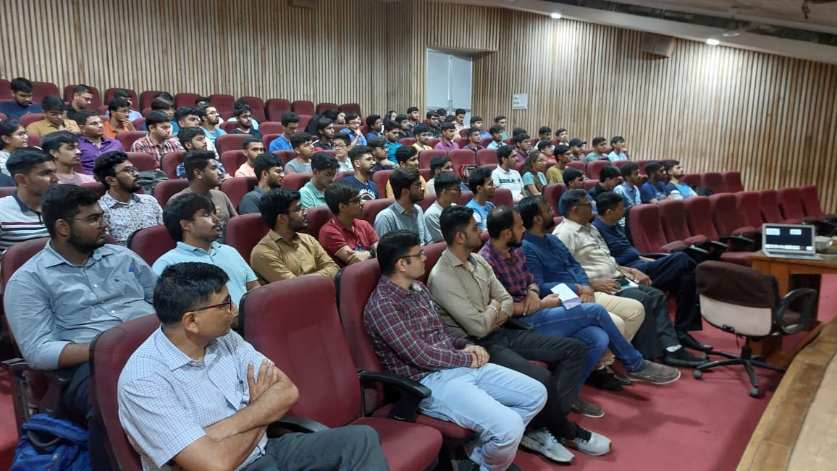 | 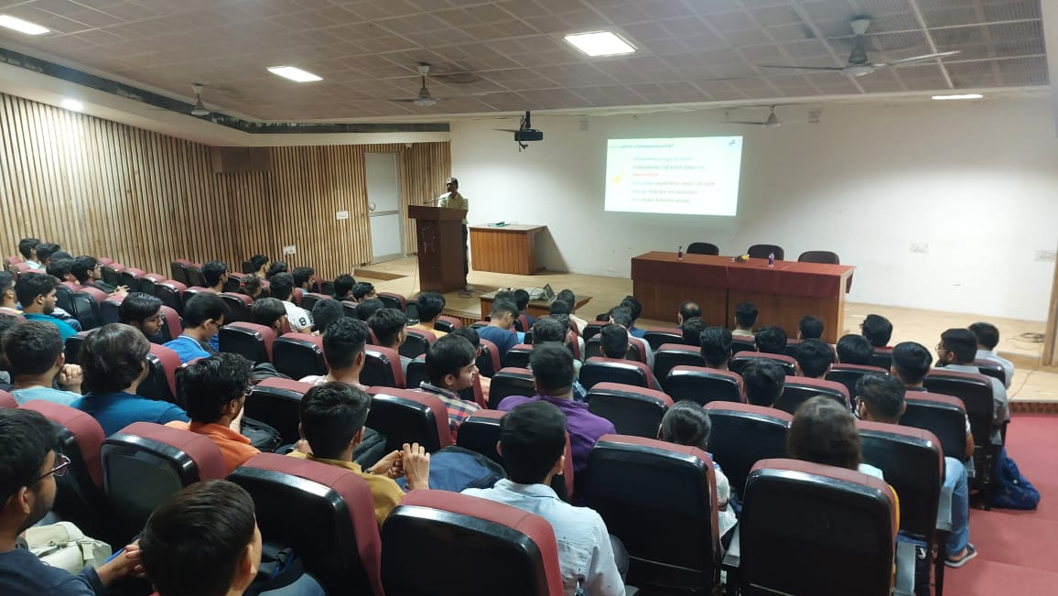
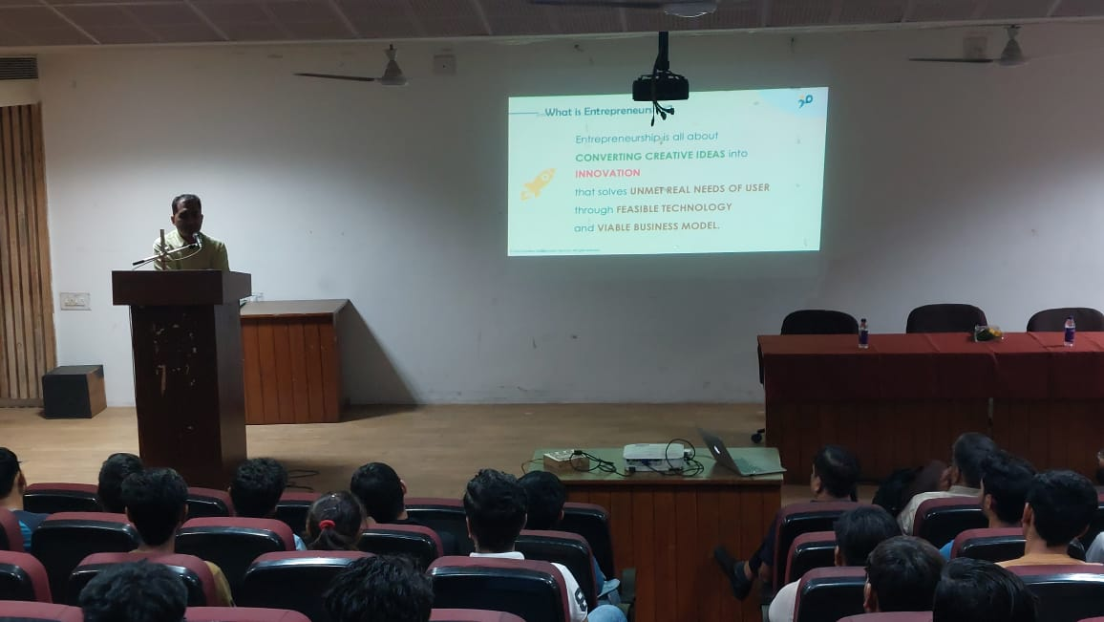 | 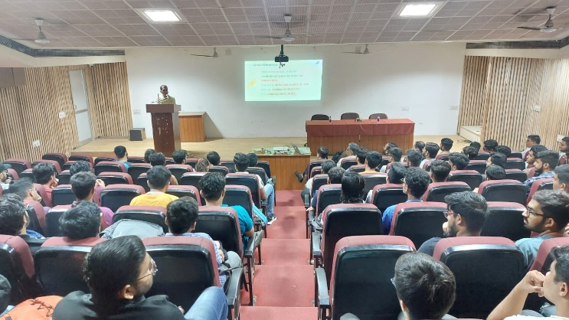
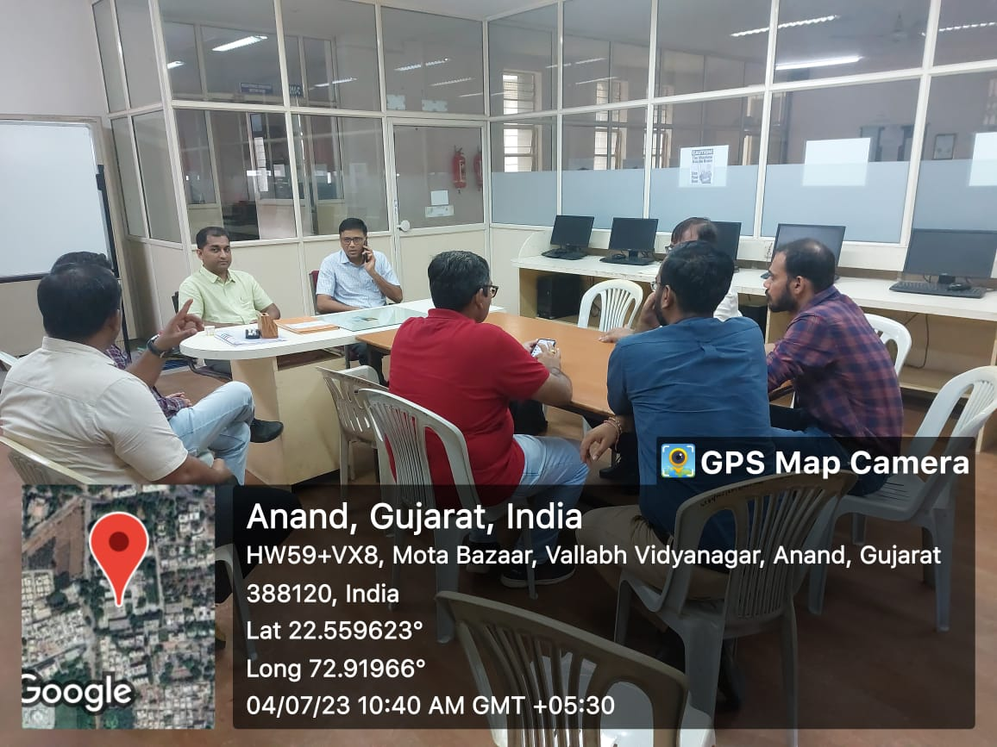 | 