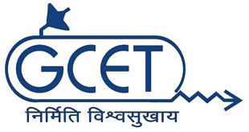
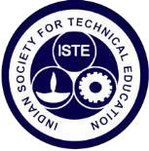
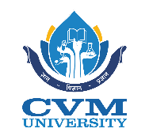

Indian Society for Technical Education

“Draw Express – Online Game Event ”

Organized by

Department of Computer Engineering

and

GCET ISTE STUDENT CHAPTER

DATE: 8TH September, 2020

FACULTY COORDINATOR:

Prof.Kinjal Joshi

STUDENT COORDINATORS

Sakshi Patel

Vandana Luhana

Nishi Patel

CONTENTS

- About ISTE

- Draw Express: An Overview

ABOUT ISTE

The Indian Society for Technical Education (ISTE) is the leading National Professional non-profit making Society for the Technical Education System in our country with the motto of Career Development of Teachers and Personality Development of Students and overall development of our Technical Education System. At present, ISTE has a very large and an effective membership base consisting of more than 1,02,985 Life Members, 5,54,094 Student Members, 2410 Institutional Members (including IITs, IISc, NITs and other leading technical institutions), 1214 Faculty Chapters and 1322 Students’ Chapters and 17 Sections throughout the country.

The major objective of the ISTE is to provide quality training programs to teachers and administrators of technical institutions to update their knowledge and skills in their fields of activity and to assist and contribute in the production and development of top-quality professional engineers and technicians needed by the industry and other organizations. Recently GCET ISTE student chapter was given the best student chapter in Gujarat

Draw Express – An Overview

This event was mainly organized to rejuvenate young and fresh mind from daily chores. It was an interactive event. It showed how different people have varied perspectives of drawing a single word.

It was not only about how well the participant can draw, although that helped but other key factors were : how the participant can relay the message of the drawing , vocabulary and imagination. Hundreds of words from basic to more challenging were included to the game.

Picture summary of the event :

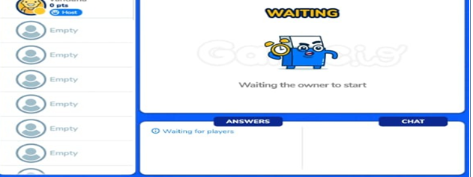 | 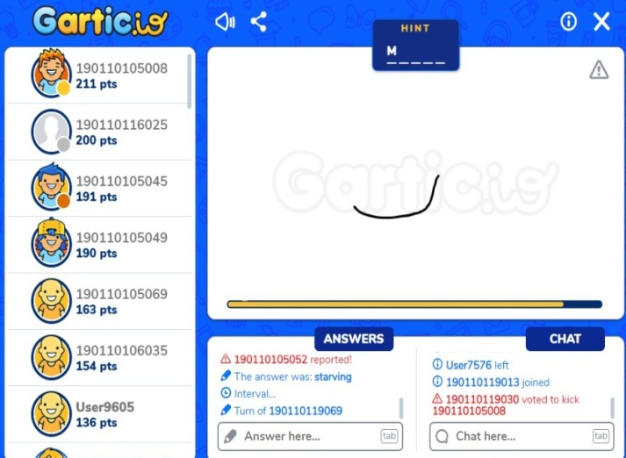
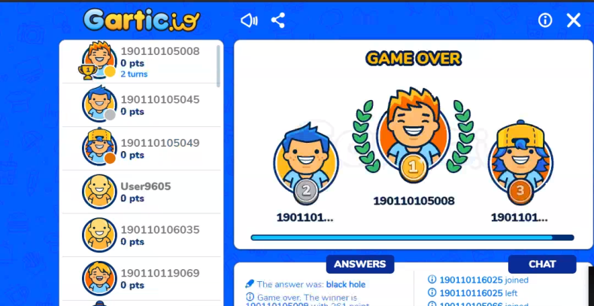 | 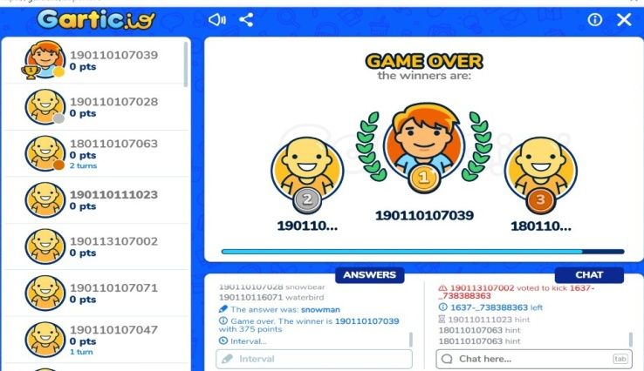

Conclusion:

Total 65 participants took part enthusiastically and had great experience with vibrant and colorful visuals. Everyone enjoyed the event and had given positive feedback.

