Indian Society for Technical Education

“Workshop on Android Studio”

Organized by

DEPARTMENT OF COMPUTER ENGINEERING

and

GCET ISTE STUDENT CHAPTER

DATE: 1st September, 2020

FACULTY COORDINATOR:

Prof. Kinjal Joshi

STUDENT COORDINATORS

Shrey Jagad

Dhruiv Topiwala

CONTENTS

- About ISTE
- Workshop Overview
- Conclusion

ABOUT ISTE

The Indian Society for Technical Education (ISTE) is the leading National Professional non-profit making Society for the Technical Education System in our country with the motto of Career Development of Teachers and Personality Development of Students and overall development of our Technical Education System. At present, ISTE has a very large and an effective membership base consisting of more than 1,02,985 Life Members, 5,54,094 Student Members, 2410 Institutional Members (including IITs, IISc, NITs and other leading technical institutions), 1214 Faculty Chapters and 1322 Students’ Chapters and 17 Sections throughout the country.

The major objective of the ISTE is to provide quality training programs to teachers and administrators of technical institutions to update their knowledge and skills in their fields of activity and to assist and contribute in the production and development of top-quality professional engineers and technicians needed by the industry and other organizations. Recently GCET ISTE student chapter was given the best student chapter in Gujarat

Workshop Overview

This workshop was organized for 2nd and 3rd year Computer Engineering students. The workshop was conducted by a 3rd Year Computer Engineering Student named Dhruv Topiwala. He covered the basics of Android Studio and web integration in Android. Total 80 students have participated in the workshop.

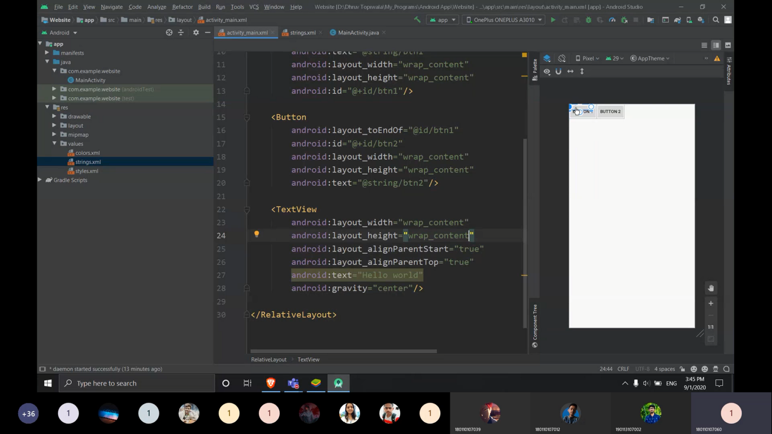

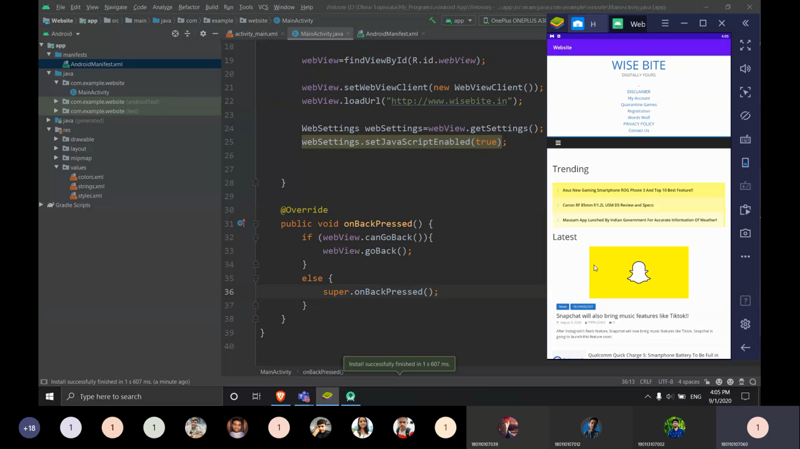

CONCLUSION

Participants learn the basics of Android Studio and Integration of a website on an Android device.

