G. H. Patel College of Engineering & Technology

INDUSTRIAL VISIT

Enviro Infrastructure Company Ltd. (EICL) Padra, Vadodara on 5/2/19 (Tuesday).

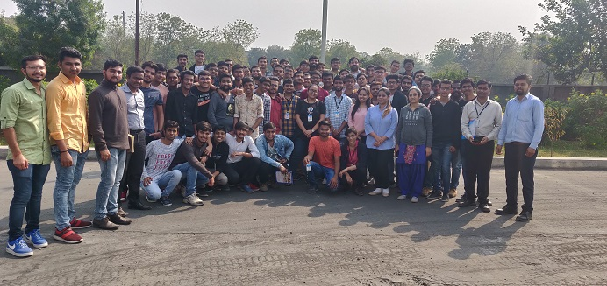

The Chemical Engineering Department, GCET had organised an industrial visit to Enviro Infrastructure Company Ltd. (EICL) Padra, Vadodara on 5/2/19 (Tuesday). 60 students of second year chemical engineering along with Prof. Endrick D. Contractor and Mr. Ashok Gajera had attended the visit. EICL is Industrial Common Effluent Treatment Plant committed to maintain ecological balance. The Plant has 115 members(ONGC being one of them) sending it's Effluent for treatment, before disposal and the plant has capacity of 4.5KL since 2015.Majority members are of chemicals, Pharma, Glass industries and oil based industries. For the visit the students were divided in group of 15, each group with a company employee as the guide. Their prime focus of treatment is through biological methods. Initially, all the parameters of Effluent are tested at laboratory scale and then taken at larger scale if found suitable. First step is to neutralize the effluent then sludge separation, followed by bio-mass addition and aeration. Further, Water separated by decanter is then passed through combined layer of sand filter and activated charcoal. The properties of water are tested and then disposed. Sludge obtained from the process is packed and transported for the disposal. The water now becomes safe to release. Visit seemed to be very much helpful for students as it helped them update technically and think in that direction.

