G.H. PATEL COLLEGE OF ENGINEERING AND TECHNOLOGY


INTERNATIONAL SOCIETY OF AUTOMATION
DATE:26/07/18
A SIG on Graphic Design was organised from 18th July to 24th July at G.H.Patel College of Engineering and Technology by the students of ISA (international Society of Automation). Each day a lot of knowledge was imparted to the students. Following is a day to day report of the SIG.
18th July: A brief introduction of the event was given in which the difference between design and graphic design was explained. The Photoshop software was installed and it’s usage was explained. The students were taught how to create workspace, art board, adjust resolution, Background colour etc. They were taught the usage of tools, layers etc. Various tools like Hand tool, Quick Selection tool, Rectangle tool, Eye-dropper tool were taught to the students. By using a square figure, explanation was given about field colour. The students were also taught how to change the background. A self-test was also given at the end.
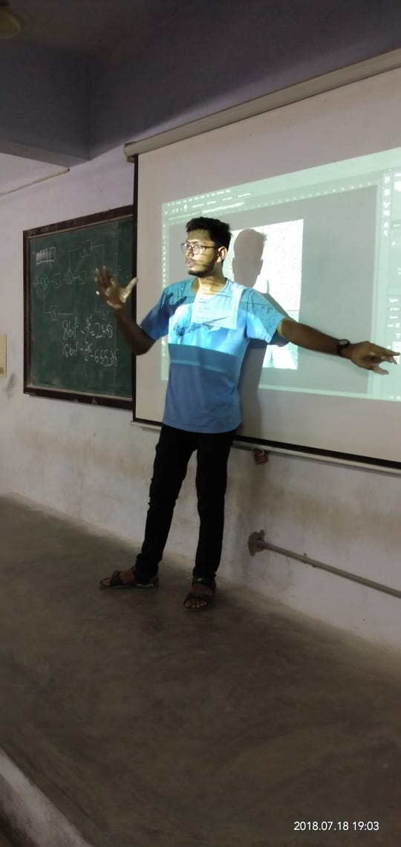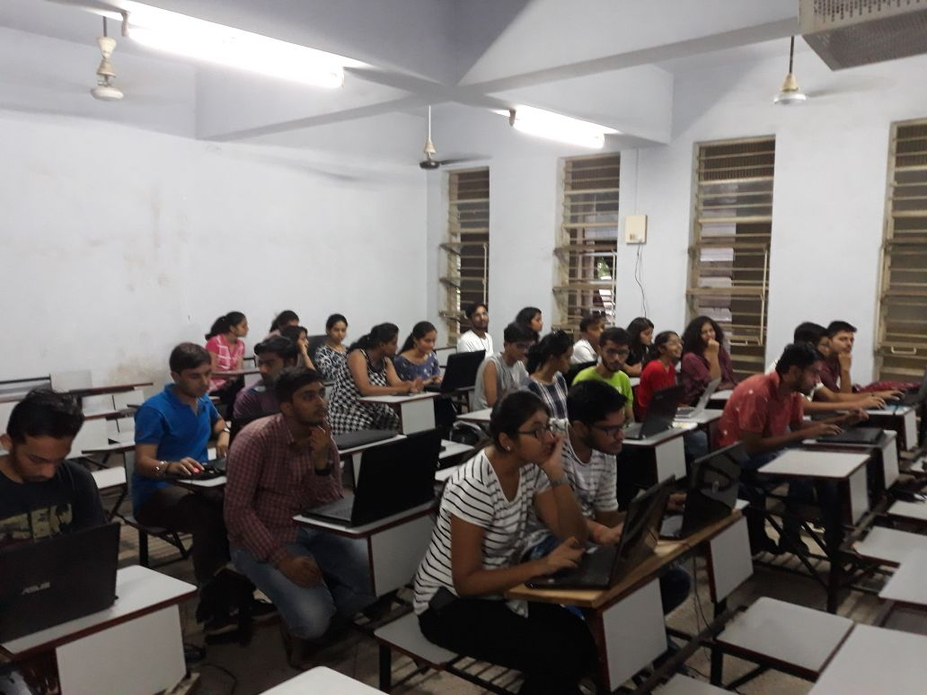

19th July; The students were taught watercolour splash and were also given a revision of what was taught in the previous class. The task given was checked and the students were given guidance regarding it.

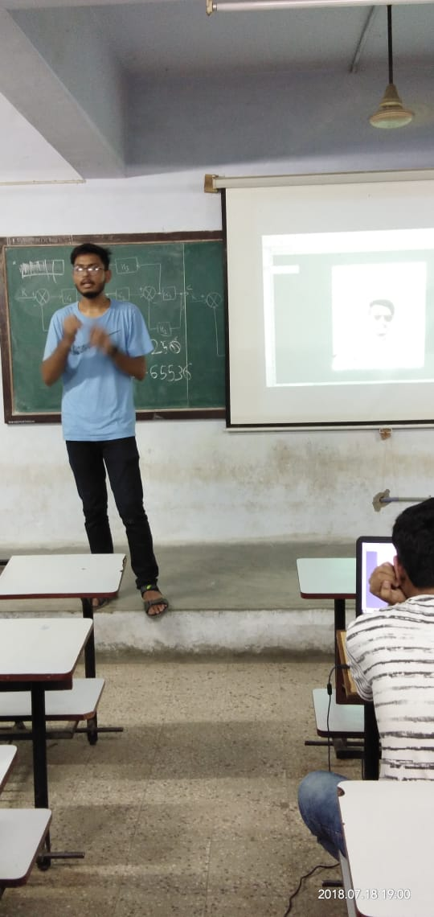
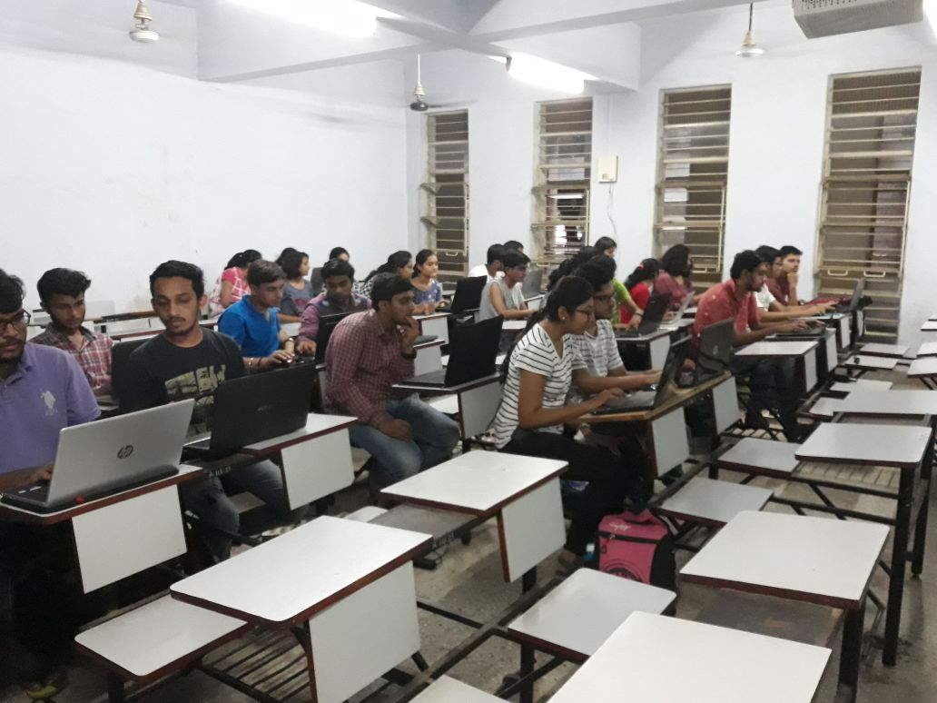

23rd July: The students were taught how to insert text, modify it,and change the fonts. They were also taught how to insert watermark. They were taught how to create their own brush for colour splashing. Colour splash- an important feature of photoshop was taught to the students. The students were taught a feature of Photoshop called as ‘Dust-effect’. They were also given a task of inserting ‘Dust-effect’ in the photograph of their own choice.

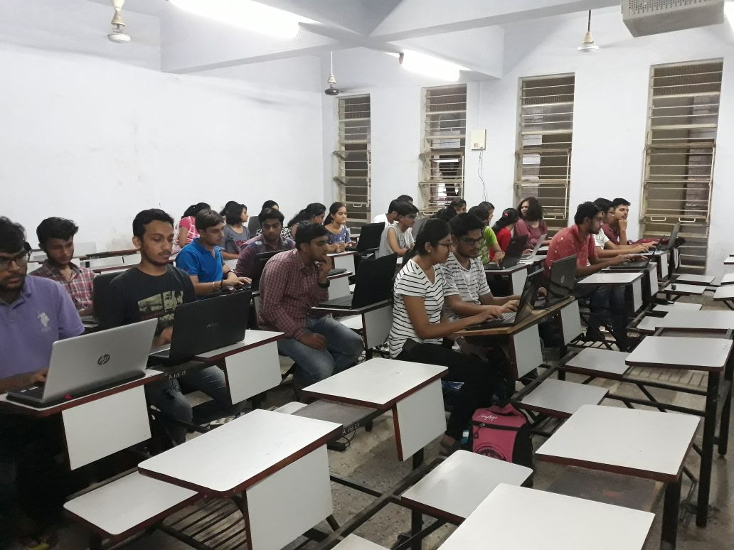
24th July: Threshold effect was taught to the students. A small task was given to the students. At the end of the SIG, Jaimin Patel was felicitated by Viraj Acharya, Chairman of ISA,GCET. Aaush Bhardwaj, a participant ,was awarded by the ISA for his excellant performance.
