G H PATEL COLLEGE OF ENGINEERING AND TECHNOLOGY
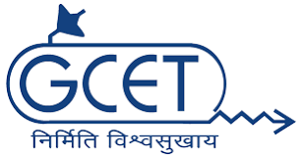
INTERNATIONAL SOCIETY OF AUTOMATION(ISA)

DATE-9/8/2018
An event called as ‘Miniesta 1.1’ was organised by GCET ISA Student Chapter and Minions Robotics Club on 7th August, 2018. The seminar aimed at improving the knowledge of the students in the field of robotics. The event was divided into morning session and afternoon session.
Morning Session
The morning session began with a prayer and felicitation of our esteemed chief guests Dr. Vijay Makwana Sir (HOD Electrical Department) and Dr. Jatin.J.Patel (Associate Professor, Electrical Engineering Department and Faculty Advisor, GCET ISA SB). Both the chief guests spoke in length about the importance of robotics in the industry in the upcoming years. Viraj Kathe, a member of team Minions gave the introduction of Minions Robotics Club and ISA. The Chairman of GCET ISA SB and Team Minions, Viraj Acharya too gave his introduction and briefed the students about the work done by GCET ISA STUDENT SB and Team Minion.
He discussed various kinds of defences that are to be used during a Robo-War event. Various kinds of weapons like Rammers , Blades like ‘Saw blades’, ‘Spinners’, ‘Thwackbot’, ‘Torque Reaction’, ‘Lifter’, ‘Flipper’ etc, armours like ‘Traditional’, ‘Ablative’ and ‘Reactive’, attacking devices etc were discussed. Various kinds of robots, namely ‘Horizontal’ and ‘Vertical’, ’Drum’, ‘Crusher’ were discussed and their construction was explained. Various kinds of Robot structures were explained like ‘SCARA’, ‘Tricept’ and ‘Hexapud’, ‘Cartesian Coordinate Robot’, ‘Cylindrical Coordinate Robot’ etc.
The session was carried on by Rushvit Mistry who discussed various aspects which are to be considered while making a robot. He discussed about various factors like
- Weight Classes
- Scale factor
- Design
- Calculations
- Optimization
- Building and Testing
- Types of Wheels
- Payload Capacity
- Weapon Systems
- Battery Life
- Remote Controller
- Rules and Regulations of various Robotic Events.

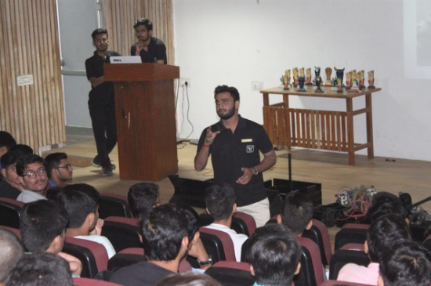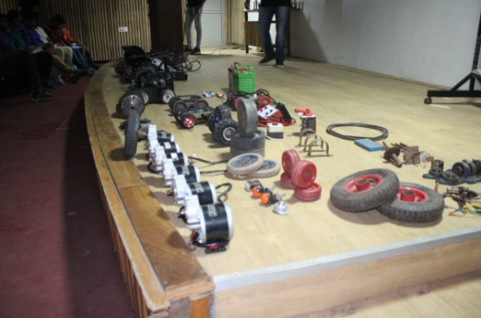

Afternoon Session:
After the lunch the students were taught about the various materials which are used to build up a robot. The applications of those materials was also taught to the students. They were shown videos of various Robo-Wars and were taugt different kinds of attack and defense moves. Usage of different kind of weaponry was also explained. The students were introduced to the ‘Team Beast’ who also are from GCET and specialise in Robotics based events(not related to fighting). Various kinds of Robotics based events were explained to the students.

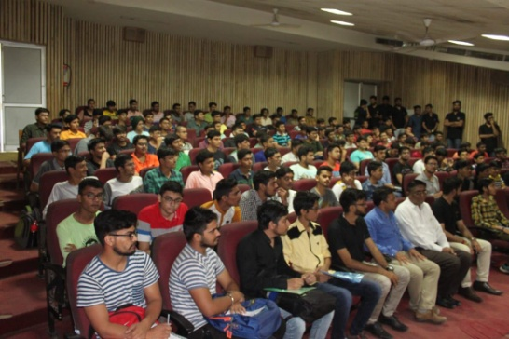

The session was concluded with a doubt solving session in which various doubts of the students were solved . A positive feedback was provided.

